LAB Network Load Balancer
Network load balancer configuration same like ALB, only change listener (TCP)
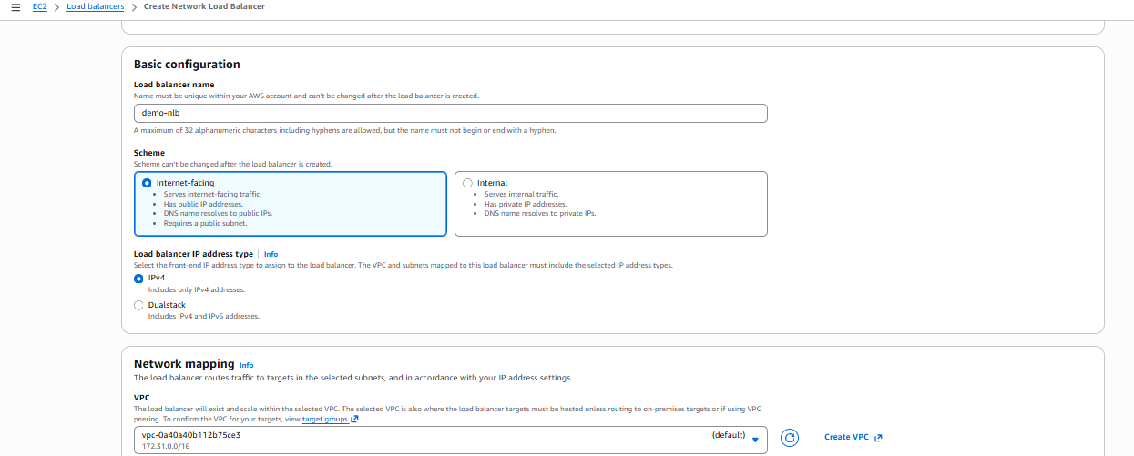
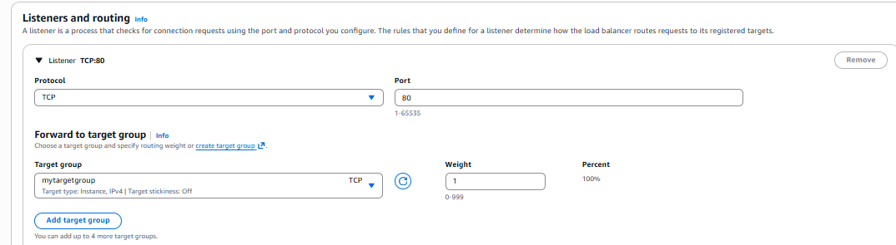

Able to login via a NLB DNS
